


Srishyla Educational Trust®

GM UNIVERSITY
(Established under the Karnataka State Act No.19 of 2023) Post Box No.4, Davanagere - 577006

Project Based Learning Semester: I
(UE25CS1106)
PBL Report

“DIGITAL VOTING SIMULATION APP”

Section- "AI1B"

Submitted By,

IMRAN HASHMI - U25E01AI050
KARTHIK - U25E01AI053
KEETRTI S BINJADAGI - U25E01AI056
KEERTHANA R - U25E01AI055

PBL Coordinator Guide

Mr. MOHAMMAD ZEESHAN M Ms. RAKSHITA
Asst. Professor Asst. Professor
Dept. of AIML Dept. of AIML

CONTENTS

S.No. | Title | Page No.
1 | Abstract | 1
2 | Introduction | 2
3 | Problem Statement | 3
4 | Objectives | 4
5 | Software Components Required | 5
6 | Methodology | 6

1. ABSTARCT

This project presents the frontend development of a Digital Voting Simulation Application, designed to replicate the core experience of electronic voting in a secure, educational, and user-friendly format. Built entirely using HTML, CSS, and JavaScript, and visually enhanced with design assets from Canva, the application simulates key stages of the voting process—voter login, candidate selection, vote casting, and result display—within a clean and responsive interface.
The goal is to promote civic awareness and digital literacy by offering users an interactive platform that mimics real-world voting systems without relying on backend infrastructure. The interface is structured with semantic HTML, styled using responsive CSS, and powered by JavaScript to enable dynamic behaviors such as form validation, vote tracking, and real-time result updates.
Canva is used to design custom icons, banners, and UI mockups that reflect democratic themes and ensure visual consistency. The project emphasizes accessibility, modular design, and performance optimization, serving as a practical demonstration of frontend development skills and a foundation for future enhancements.
Ultimately, this simulation app provides a hands-on, engaging way to explore the mechanics of digital voting, making the democratic process more approachable and understandable for users of all backgrounds.
.

2. INTRODUCTION

Voting is the foundation of democratic participation, yet many individuals—especially students and first-time voters—lack exposure to how digital voting systems function. In an increasingly digital world, understanding the mechanics of electronic voting is essential for civic awareness and technological literacy.
This project introduces a Digital Voting Simulation Application, developed entirely using HTML, CSS, and JavaScript, with visual assets designed in Canva. The goal is to create an interactive, educational platform that simulates the voting process in a secure and user-friendly environment. By mimicking real-world voting stages—such as voter login, candidate selection, vote casting, and result display—the app offers users a hands-on experience without requiring backend infrastructure or sensitive data handling.
The frontend interface is built with a mobile-first approach, ensuring accessibility across devices. Semantic HTML provides structural clarity, CSS adds responsive styling and visual appeal, and JavaScript powers dynamic behaviors like form validation, vote tracking, and result visualization. Canva is used to design civic-themed icons, banners, and UI mockups that enhance the overall user experience.
This simulation serves as a practical demonstration of frontend development skills while promoting civic engagement. It is ideal for educational settings, awareness campaigns, or as a prototype for future digital voting platforms.

3. PROBLEM STATEMENT

Traditional voting systems are often slow, manual, and prone to human errors. Our challenge: build a Digital Voting Simulation App that transforms abstract civic concepts into an interactive experience—using HTML, CSS, JavaScript, and Canva to create a story-driven, gamified, and visually rich platform. The goal is to make voting feel personal, accessible, and memorable for learners across diverse backgrounds.

4. OBJECTIVES

- Build a structured frontend interface using semantic HTML5 to represent key stages of the voting process: login, candidate selection, vote casting, and result display.
- Design civic-themed visual assets using Canva, including banners, icons, and UI mockups that reflect democratic values and enhance user engagement.
- Style the application with responsive CSS3, ensuring compatibility across devices and screen sizes while maintaining a clean and professional look.
- Implement dynamic behaviors with JavaScript, such as form validation, vote tracking, and real-time result updates—all without backend dependencies.
- Ensure mobile-first responsiveness, using media queries and flexible layouts to provide a smooth experience on smartphones, tablets, and desktops.
- Test and optimize the interface for usability, performance, and accessibility, ensuring that users of all backgrounds can interact with the simulation easily.
- Promote civic awareness and digital literacy by offering a hands-on, frontend-only experience that mimics real-world voting systems in a safe and educational format.
- Simulate real-world voting logic using JavaScript to mimic vote counting, candidate selection limits, and result calculation—offering users a realistic experience without backend processing.
- Visualize voting outcomes through dynamic charts or styled result panels, helping users understand how votes translate into outcomes in a clear, engaging format.

5. METHODOLOGY

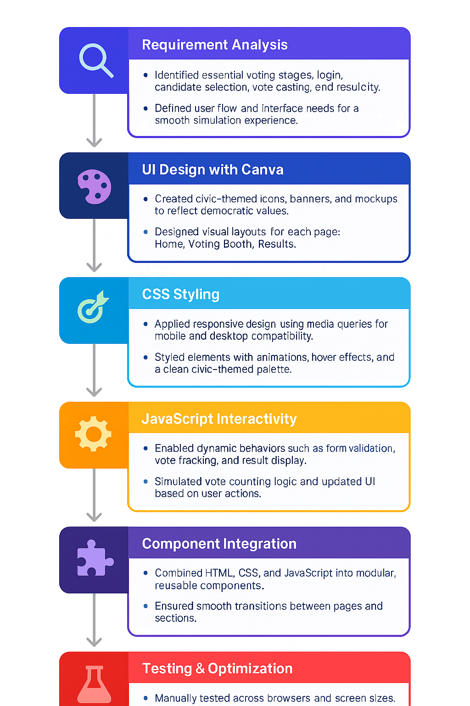

- Manually tested across browsers and devices.
Testing & Optimization

6.SOFTWARE AND HARDWARE REQUIREMENTS

- HTML5 – Structure the voting interface
- CSS3 – Style the layout with civic-themed visuals
- JavaScript – Power vote logic and interactivity
- Canva – Design banners, icons, and UI mockups
- Visual Studio Code – Code editor for development
- Live Server – Real-time preview while coding
- Web Browser – Test and demo the simulation
- Git & GitHub – Version control and project hosting
- DevTools – Inspect, debug, and refine the frontend
Let me know if you’d like this styled as a checklist or turned into a visual card for your report or slides!

